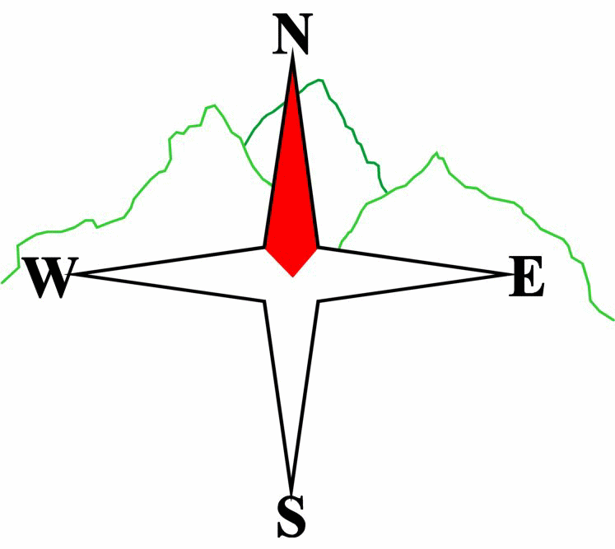 ***Blairgowrie & District Hillwalking Club***

**www.bdhc.org.uk**

**Ben Gulabin**

**24/11/2024**

**O.S. Map No**: 43

|  |  |  |  |  |
| --- | --- | --- | --- | --- |
| **Bus times:** | **Blairgowrie** (**Wellmeadow**): **08.00 am** | | **Alyth** (**Square**): **07.45 am** | |
|  |  | | | |
|  | | | | |
| A Walk – Ben Gulabin via Carn Bhinnein from Cairnwell | | | | |
| Start at Cairnwell ski centre NO 138 782. Go westwards up the track towards Loch Vrotachan. From the col traverse southwards to pt 808. Follow ridge SW to **Carn nan Sac (M top 920m)** then W to **Carn a’ Gheoidh** **(M 975m)**. Continue W then S to **Carn Bhinnein** **(M top 915m)** for spectacular views on a clear day. Return to lochan at pt 854 then traverse eastwards round corrie to pt 829. Follow track southwards over Carn Mor to **Ben Gulabin (C 806m)**. Descend N into Coire Shith. (The Alllt Coire Shith is the start of the Shee Water.) Turn W to pick up feint path on N of burn going down to Gleann Taitneach. Cross Allt Ghlinn Thaitneich by footbridge. Follow W bank down to Dalmunzie Hotel. Here, refreshments may be taken. | | | | |
| Approx. distance: 18.4 km | | Total ascent: 750 m | | Min. **walking** time: 6 ¼ hrs |
|  | | | | |
| B Walk – Carn Ait | | | | |
| Start at the Spittal of Glenshee NO 110 698. Cross the A93 and follow the Cateran Trail to Tomb. Turn N up a track that passes east of Bad an Loin. Keep right at a junction to its NE, 124 709. Follow this N then NE to its end S of Sron na Fionnach. Climb E to summit of Carn Chom-Stri (718m). Follow ridge NNE over Carn Aig Mhala to summit of **Carn Ait (C top 864m)**. Then walk E to col at 151 732 turning S to meet the start of a track at 148 719. Follow this down to where it meets the Cateran Trail. Turn right and follow NW back to start. Drive to Dalmunzie for refreshments and to meet the other club member.. | | | | |
| Approx. distance: 17.7 km | | Total ascent: 734 m | | Min. **walking** time: 6 hrs |
|  | | | | |
| C Walk– Cateran Trail from Lair to Spittal | | | | |
| Start at junction of B951 with A93 nr Lair, NO 142 633. Walk to where the Cateran Trail heads to Dalnaglar Castle app 1 Km from start. Follow Cateran Trail N to the Spittal of Glenshee. Continue to Dalmunzie Hotel for refreshments and to meet the other club members. | | | | |
| Approx. distance: 13.6 km | | Total ascent: 300 m | | Min. **walking** time: 5 hrs (@ 3 kph) |

____________________________________________________________________________________________________

|  |  |
| --- | --- |
| IMPORTANT: YOUR SAFETY IN THE HILLS | |
| **The Committee reminds members and guests of the following important points:** | |
| * You are responsible for your own safety * Club officials are not trained mountain leaders * Are you fit enough to complete your chosen walk in the available time? * Know where you are going on the walk and follow the route on your map. * Know how many are in your party and stay together | * Ensure you have enough food plus emergency rations * Carry a map & compass, survival bag, torch, whistle and small first aid kit. Know how to use them. * In winter conditions you must carry an ice axe on high level walks (club rule). You are also recommended to carry crampons. * **Learn** how to use your equipment. |
|
|
|
|
|  |
| **Club officials will be happy to give advice on any of these points if requested.** | |

The next club walk is on the **15th December- Xmas Walk** to Glen Isla starting at 07.45 am (Blairgowrie) and 08.00 am (Alyth). There will also be an informal **‘Twixt’ meet 27-29 December at Aviemore**.

**Please note that the Minimum walking times are based on reasonably fast walkers and assuming good conditions. The times do not include stops or breaks.**

## **In poor weather conditions or if members are not comfortable walking at 4km/hour then alternative or shorter routes should be considered.**